Problem 3

Fibonacci numbers
Level: Easy

Given an unsigned integer n, compute the nth Finonacci number F_{n} according to the equation:
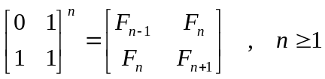
Please put the result into a 4 bytes unsigned integer. If F_{n} overflows, your program shall report so.

Sample test
Input:
Filename:
3.in
Format:
There are 10 lines to stand for 10 cases. Each line contains an integer number, n.

Output:
Filename:
3.out
Format:
- For each case, the first line is a prompt as following: “case 1:”.
The next line is the answer.
- Print a word, “overflow”, if the n is too large.
- The last line of each case is an empty line, even if the result is overflow.

Example:
Input:
1
25
48

Output:
case 1:
1

case 2:
75025

case 3:
overflow

All inputs are from stdin and outputs to stdout.

